|  |  |  |  |
| --- | --- | --- | --- |
|  | Bansilal Ramnath Agarwal Charitable Trust's  Vishwakarma Institute of Information Technology  **Department of**  **Artificial Intelligence and Data Science** | | |
| Name: Siddhesh Dilip Khairnar | | | |
| Class: SY | Division: B | | Roll No: 272028 |
| Semester: IV | | Academic Year: 2022-2023 | |
| Subject Name & Code: Software Engineering, ADUA22204 | | | |
| Title of Assignment: To write User stories. | | | |

Aim: **Write the user stories.**

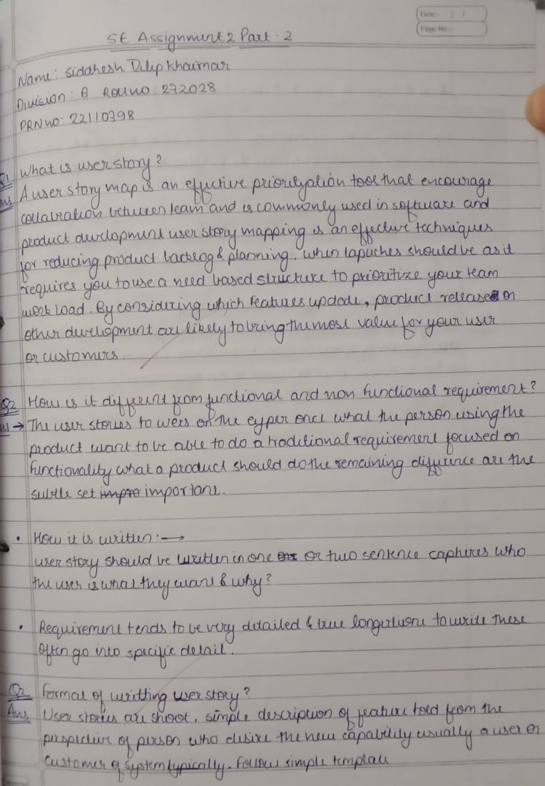

Conclusion: Hence, we have successfully implemented user stories.